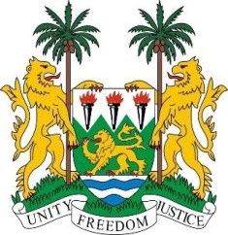
SIERRA LEONE

21st Session of the UPR

ARMENIA

22 January 2015

Mr President,

Sierra Leone welcomes the delegation of Armenia and thanks them for their detailed national report which details the progress made since their last review.

My delegation commends Armenia on the efforts to promote human rights and in particular, Sierra Leone notes the National Plan of Action for Human Rights Education 2012 – 2015 and the National Programme for the Protection of Children’s Rights 2013 – 2016.

My delegation would however urge Armenia to more effectively enforce laws to prevent early marriages in some communities, especially in the case of Yezidi girls. Sierra Leone also calls on Armenia to refrain from prosecuting asylum seekers for illegal entry and to ensure effective access to education by minorities, asylum seekers and refugees.

Sierra Leone has the following recommendations:

- Ratify ICRMW and accede to the optional protocols of the CRC-IC.

- Submit its overdue report to the relevant treaty bodies.

- Implement comprehensive legislation to effectively combat the widespread cases of violence against women and offer further protection to victims of domestic violence.

- Prosecute and monitor cases of incitement to racial discrimination and racist propaganda.

Sierra Leone wishes Armenia every success in completing this review process.

Thank you, Mr President.

